- Scatter plot
weight <- c(60, 65, 70, 72, 75)
height <- c(170, 175, 168, 180, 178)
plot(weight, height,
main = "Weight vs Height",
xlab = "Weight (kg)",
ylab = "Height (cm)",
col = "blue",
pch = 19)
output:
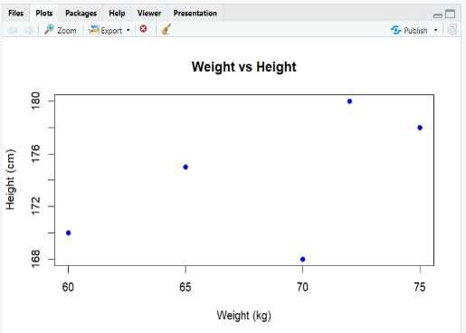

- Line plot
year <- c(2010, 2011, 2012, 2013, 2014)
population <- c(1000, 1020, 1040, 1060, 1080)
plot(year, population, type = "o", col = "blue",
main = "Population Growth Over Years",
xlab = "Year", ylab = "Population (millions)")
output:
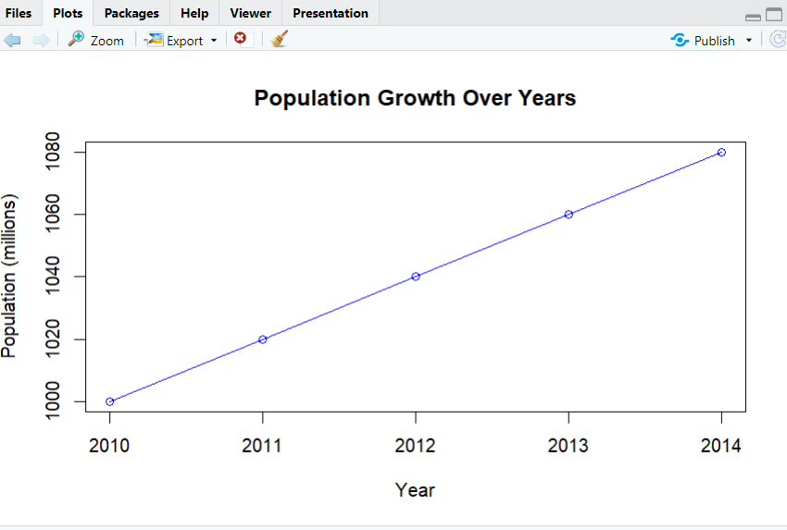

3. Bar Plot
product <- c("A", "B", "C", "D", "E")
sales <- c(300, 450, 500, 350, 400)
barplot(sales, names.arg = product, col = "skyblue",
main = "Sales by Product",
xlab = "Product", ylab = "Sales")
output:
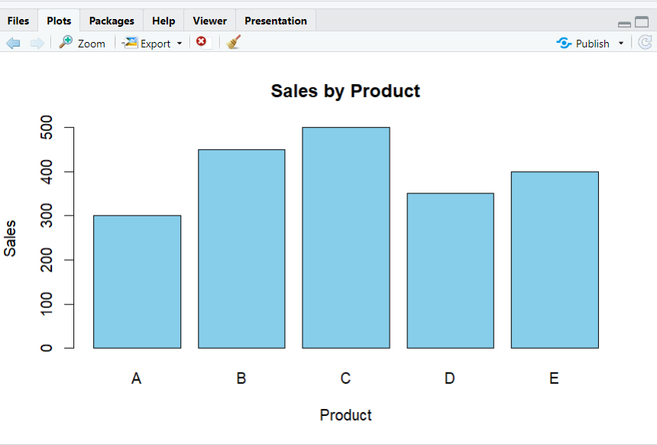

4. Histogram
age <- c(25, 30, 35, 40, 45, 50, 55, 60, 65, 70)
hist(age, col = "lightgreen",
main = "Age Distribution",
xlab = "Age",
ylab = "Frequency")
output:
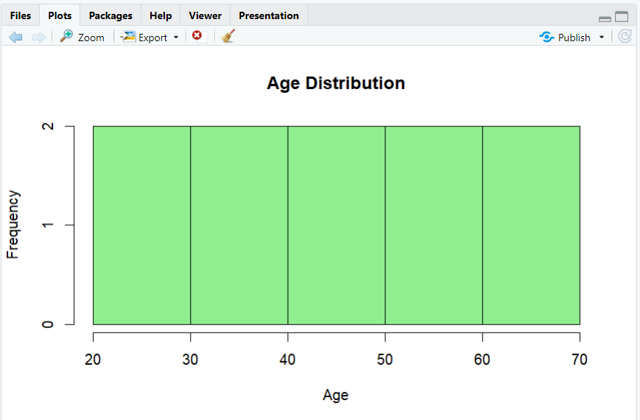
5. Pie Chart
company <- c("A", "B", "C", "D")
market_share <- c(20, 30, 25, 25)
pie(market_share, labels = company, col = rainbow(length(company)),
main = "Market Share by Company")
Output:
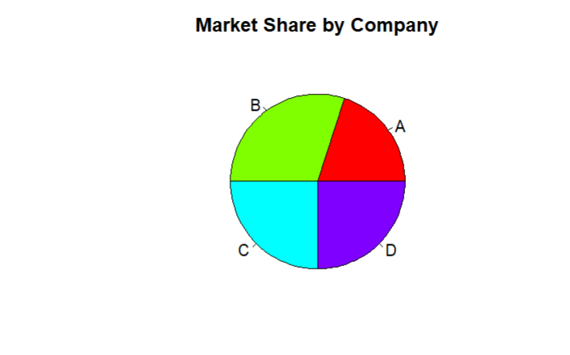
6. Box Plot
class <- c("A", "A", "A", "A", "B", "B", "B", "B")
scores <- c(85, 90, 78, 92, 88, 76, 80, 84)
boxplot(scores ~ class, col = "lightblue",
main = "Exam Scores by Class",
xlab = "Class", ylab = "Scores")
output:
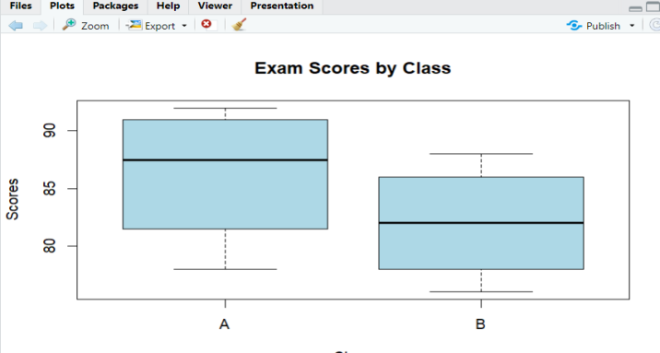
- DenistyPlot
weight <- c(60, 65, 70, 75, 80, 85, 90, 95, 100)
plot(density(weight), col = "blue", lwd = 2,
main = "Density Plot of Weights",
xlab = "Weight (kg)")
output:
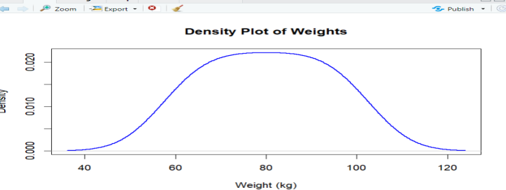

- Violin Plot

if(!require(ggplot2)) install.packages("ggplot2")
library(ggplot2)
group <- c("X","X","X","X","Y","Y","Y","Y")
score <- c(80,85,78,92,88,76,80,84)
data <- data.frame(group, score)
ggplot(data, aes(x=group, y=score, fill=group)) +
geom_violin(trim=FALSE) +
labs(title="Violin Plot of Scores by Group", x="Group", y="Score")
output:
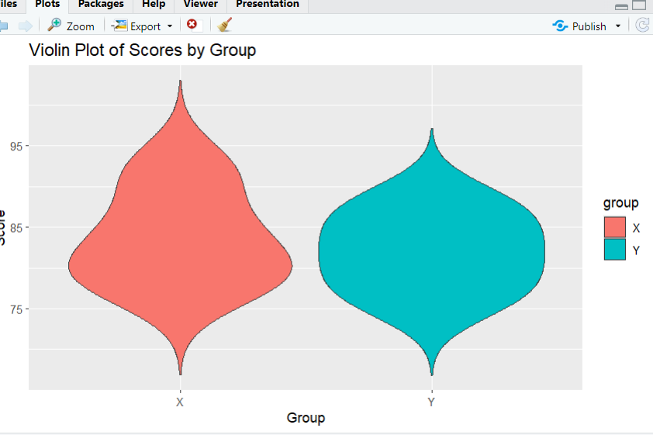
9.Heatmap
temp <- matrix(c(5,6,7,8,9, 10,11,12,13,14, 15,16,17,18,19), nrow=5, byrow=FALSE)
rownames(temp) <- c("Jan","Feb","Mar","Apr","May")
colnames(temp) <- c("CityA","CityB","CityC")
heatmap(temp, Rowv = NA, Colv = NA, col = heat.colors(10), scale = "none", main = "Monthly Temperatures")
output:
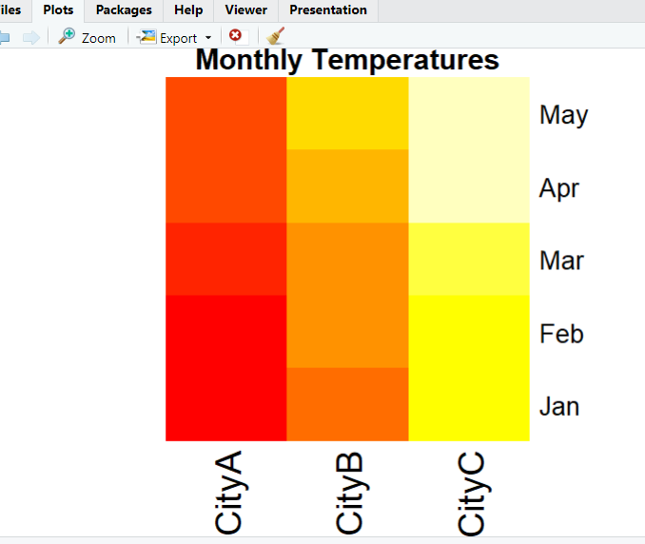
10.Facet Plot
library(ggplot2)
data <- data.frame(
month = c("Jan","Jan","Feb","Feb","Mar","Mar"),
region = c("East","West","East","West","East","West"),
sales = c(200,150,220,170,210,160)
)
ggplot(data, aes(month, sales, fill=region)) +
geom_bar(stat="identity") +
facet_wrap(~region) +
labs(title="Sales by Month and Region")
output:
